(Approx. 640 words)

Crowns and Computers
Author: Maryellen Amato, M.D., Member, ICON Users Group, MO
July 2019 issue, The ICON Newsletter
Meamato76 (at) gmail.com
www.iconusersgroup.org

Like most professions, dentistry has been deeply impacted by computer technology. Many dentists, for example, have been using digital x-rays. Several months ago in an article entitled Musings on Medicine, I discussed the advantages of using digital radiography, including quicker imaging times and decreased radiation.

Another major facet of dentistry that has been affected by computers has to do with the way dental crowns are made. A crown is a small prosthetic cap that fits over an entire tooth to restore its strength and appearance. A crown may be necessary for a variety of cosmetic and/or functional reasons. A tooth might require a crown if it is broken, racked, heavily decayed, worn, damaged in some way, or compromised by a root canal.

I had a number of crowns made back in the “old days” before the advent of computers. A tray of gooey putty was placed over my teeth for a few minutes and then the impression was sent off to a distant lab where the permanent crown was made. In the meantime, for the next two weeks I had to endure a fragile temporary crown.

All that has changed with CEREC-3d CAD/CAM. CEREC stands for “Chairside Economical Restoration of Esthetic Ceramic Crowns.” CAD/CAM stands for ‘computer assisted design/computer assisted manufacturing.”

CAD/CAM has been used in industry for many years, but dental CAD/CAM applications were not available until the 1980s, and CEREC technology has only become popular in the last decade.

My dentist, Mr. Jeff, DD, was one of the first dentists in Springfield to embrace this technology approximately 10 years ago. He has made several crowns for me with this technique, and it was so much easier than the old method – and much faster, too. Instead of taking two visits and two weeks to get the permanent crown, it only required about two hours total in one visit to have the new crown made and placed in my mouth.
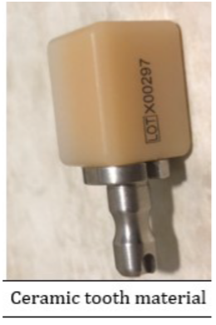
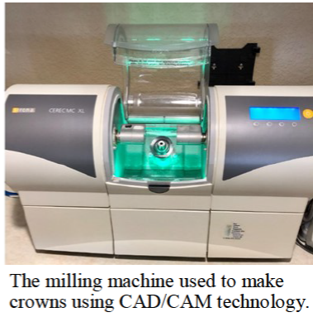
Here is what is involved: The first thing my dentist does is take a picture using a dental program which allows him to make a 3D map of my teeth, including top and side views. This allows him to design the crown chairside right then and there on his computer monitor, bypassing the need for filling my mouth with goop and sending the impression off to a lab. This computer data is then transferred wirelessly to a milling instrument that carves the crown out of a block of strong nonmetallic ceramic material. A block of a harder material is chosen for back teeth because they are subjected to stronger grinding forces. The milling machine (about two feet long by one foot wide) takes up to 30 minutes to make the crown, which is then bonded into place in the patient’s mouth.

This method is so precise that there is virtually no risk of damage to adjacent teeth. My crowns also have a very natural feel because they are customized to my bite. They blend in well with the rest of my teeth and look and feel natural.

Dr. Jeff estimates he has made approximately 3,000 crowns using CEREC CAD/CAM. Currently only about 20% of dentists in the Springfield area have this technology, so if you need a crown, be sure to check if it is available at your dentist’s office and ask how many crowns they have made using it, since like everything else with computers there is a learning curve.

In summary, I am very lucky that my dentist is on the cutting-edge of dentistry and that he could offer me this computer-based technology. I can attest from my personal experience that it is definitely easier, faster, and more accurate than the old method of creating crowns.

